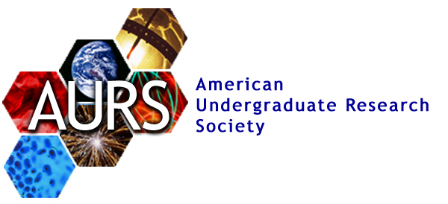
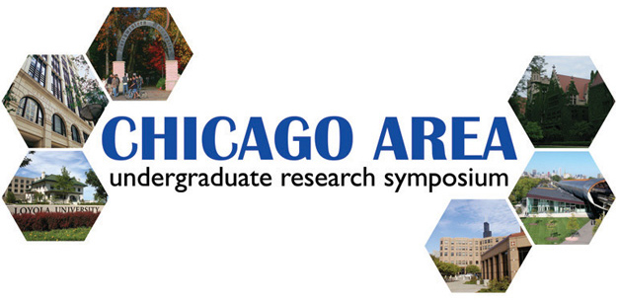
You are cordially invited to the

2007
Chicago Area Undergraduate Research Symposium

Loyola University Chicago Law Center
25 E. Pearson Street, Chicago
April 14, 2007, 10:00 am – 6:00 pm

The American Undergraduate Research Society (AURS) is proud to present CAURS, an annual event that allows hundreds of undergraduates to present their research in a professional setting. CAURS provides an excellent opportunity for students to learn about the research of their peers, interact with industry representatives, and receive both wisdom and inspiration from speakers and faculty.

RSVP to info@caurs.com
For a full schedule and details please visit www.caurs.com

You are cordially invited to the

2007
Chicago Area Undergraduate Research Symposium

Loyola University Chicago Law Center
25 E. Pearson Street, Chicago
April 14, 2007, 10:00 am – 6:00 pm

The American Undergraduate Research Society (AURS) is proud to present CAURS, an annual event that allows hundreds of undergraduates to present their research in a professional setting. CAURS provides an excellent opportunity for students to learn about the research of their peers, interact with industry representatives, and receive both wisdom and inspiration from speakers and faculty.

RSVP to info@caurs.com
For a full schedule and details please visit www.caurs.com

You are cordially invited to the

2007
Chicago Area Undergraduate Research Symposium

Loyola University Chicago Law Center
25 E. Pearson Street, Chicago
April 14, 2007, 10:00 am – 6:00 pm

The American Undergraduate Research Society (AURS) is proud to present CAURS, an annual event that allows hundreds of undergraduates to present their research in a professional setting. CAURS provides an excellent opportunity for students to learn about the research of their peers, interact with industry representatives, and receive both wisdom and inspiration from speakers and faculty.

RSVP to info@caurs.com
For a full schedule and details please visit www.caurs.com

You are cordially invited to the

2007
Chicago Area Undergraduate Research Symposium

Loyola University Chicago Law Center
25 E. Pearson Street, Chicago
April 14, 2007, 10:00 am – 6:00 pm

The American Undergraduate Research Society (AURS) is proud to present CAURS, an annual event that allows hundreds of undergraduates to present their research in a professional setting. CAURS provides an excellent opportunity for students to learn about the research of their peers, interact with industry representatives, and receive both wisdom and inspiration from speakers and faculty.

RSVP to info@caurs.com
For a full schedule and details please visit www.caurs.com

